Website Fix and Optimized Responsive for Mobile
Header Button Backoffice Frontend Remove
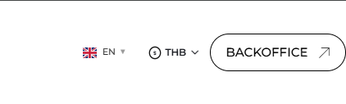
Size Header On Mobile and Desktop Check Section Gap on Home Page
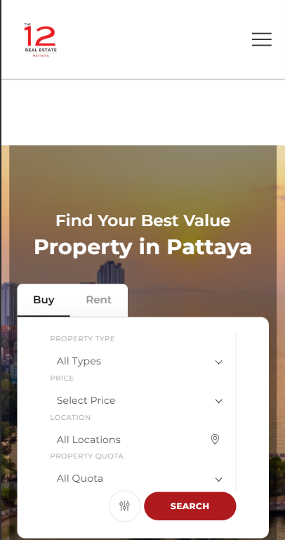

Page https://www.12realestatepattaya.com/properties?type=sale Desktop
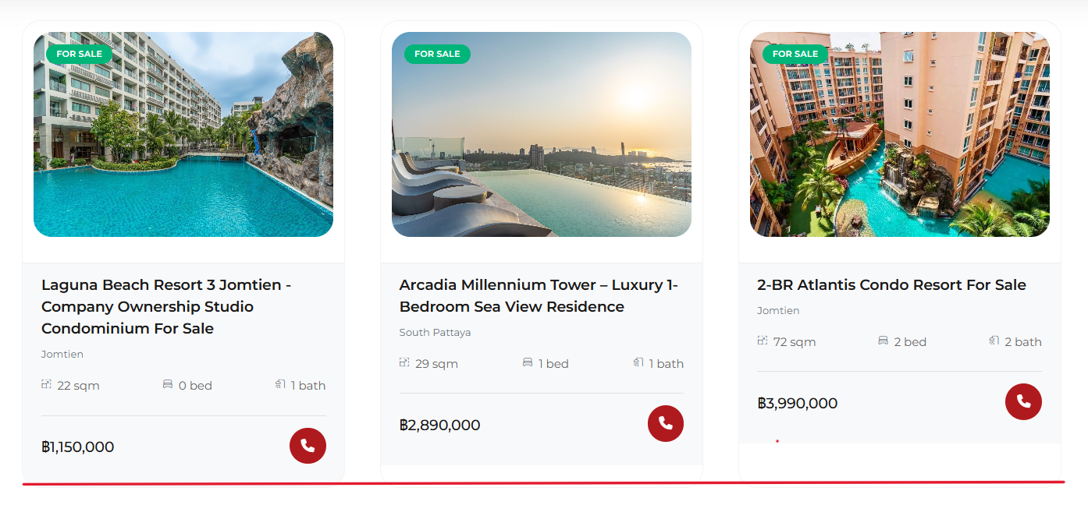

Slide Bar Preview Picture https://www.12realestatepattaya.com/properties?type=sale
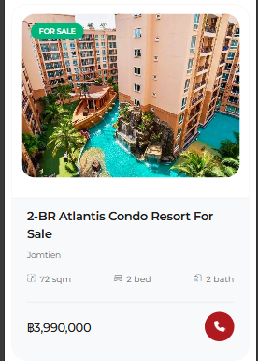

Interactive picture not working on mobile
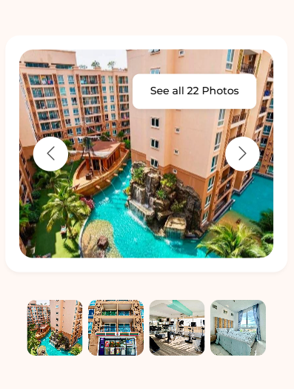
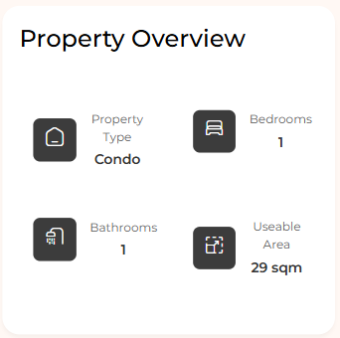

Property Detail Notworking Responsive On Mobile
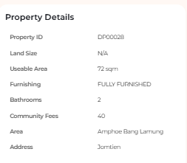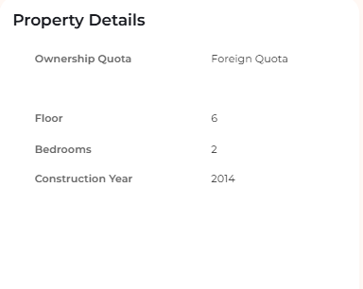
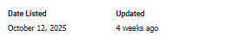< can add on?

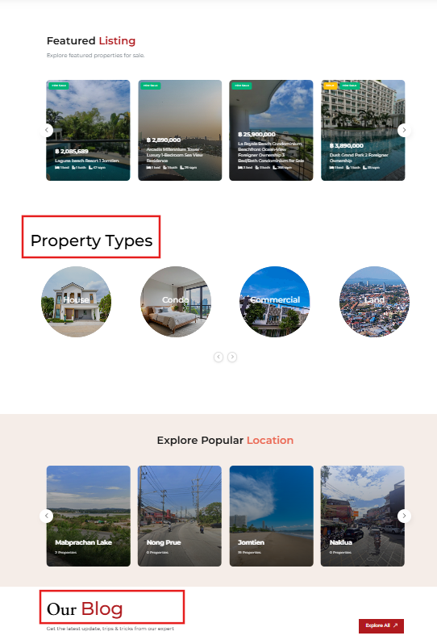
Title Text Size on mobile Size Text on Desktop
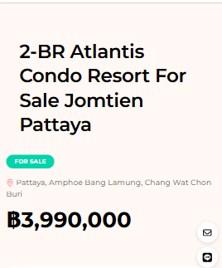
Text Our Blog and
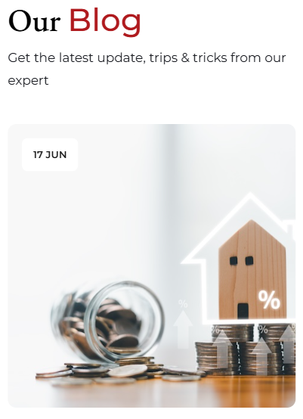

Check Update Contact information on Blackend Link Frontend

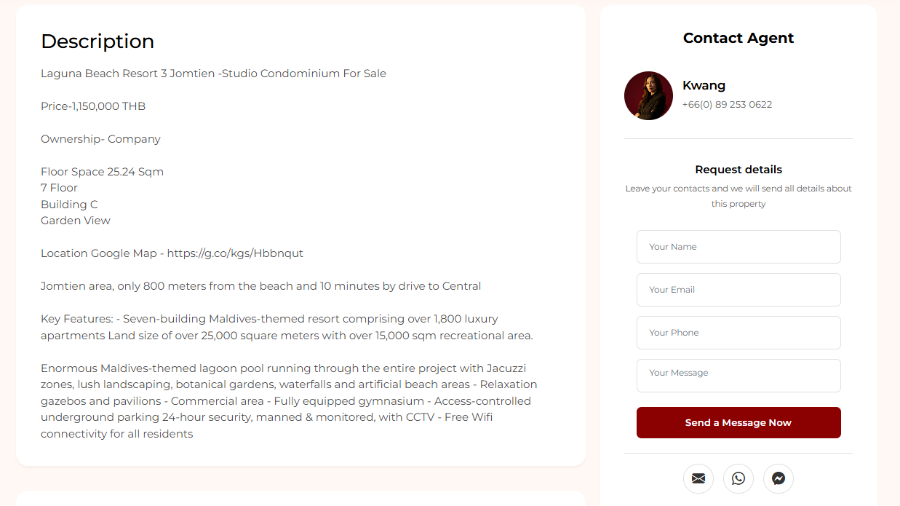
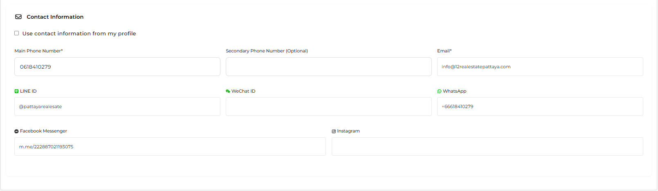
Form Contact Agent - Submission Not Working
(Field Phone Number add on country code on All Form)
Keep social icon under Form
WhatsApp: https://wa.me/+66888997944
LINE: https://lin.ee/dG5aGu4

Sticky Bar Adjust Layout and Text
Keep social icon
WhatsApp: https://wa.me/+66888997944
LINE: https://lin.ee/dG5aGu4
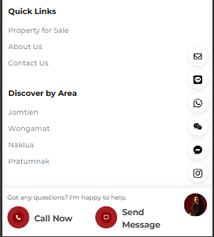
Button Alignment middle
“Call Now” Wong Number tel:088897944
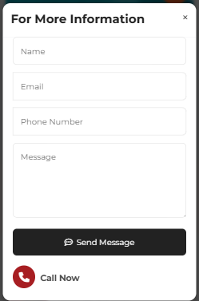

Notify - Email info@12realestatepattaya.com and CC: krittiyakwang@gmail.com

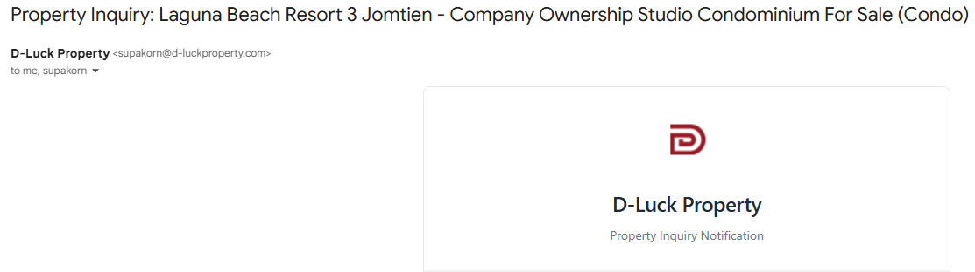

Button Unpublish Not Update On Frontend
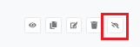
Remove the image
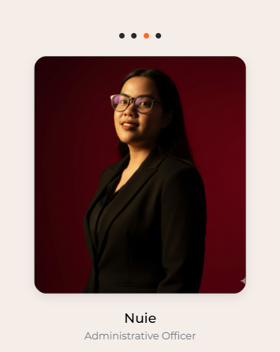

New Upload Photo: https://drive.google.com/drive/folders/1A8gaHr7FOl_zwBAk9YGHSDpxLzZXO6t9?usp=drive_link

Contact Us Page
Google Map: https://maps.app.goo.gl/J1qRZhu45YN5b3oP8
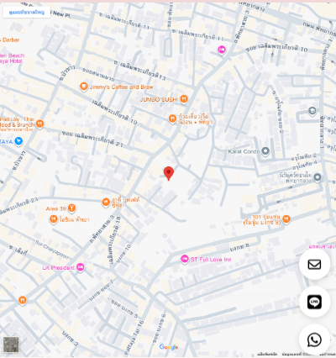

Add on Section Card (Insert before the feature listing.)
Exclusive Partners Property
Card Link to Landing Page
1. Laguna Beach Resort Jomtien > https://www.lagunabeachpattaya.com/
2. Laguna Beach Resort 2
3. Laguna Beach Resort The Maldives > https://www.lagunamaldivespattaya.com/
4. The Peak Towers > https://www.thepeaktowerpattaya.com/

https://www.12realestatepattaya.com/about < Title Tag: About | Property in Pattaya for Sale and Rent
https://www.12realestatepattaya.com/ < Title Tag: Property in Pattaya for Sale & Rent | The 12 Real Estate

https://www.12realestatepattaya.com/blog < Title Tag: Blog | Property in Pattaya for Sale and Rent

